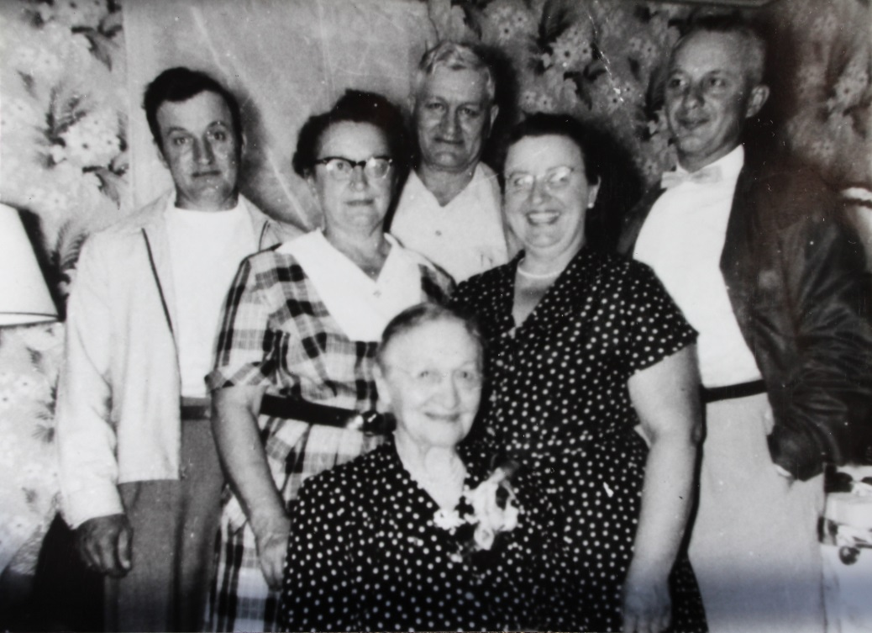

(l-r) Noah List, Wilma List Group, Philip List, Emma List Steinhauser, Luther List

Seated: Margaret (Maggie) Kern List, wife of John A. List – about 1945 (est.)

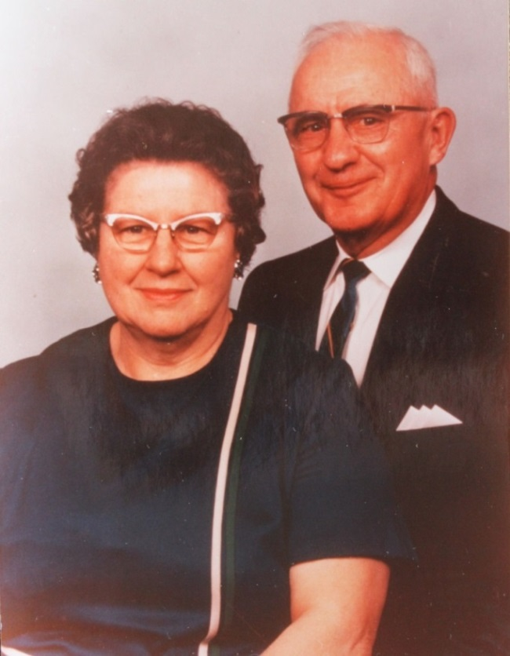

Luther J. and wife, Dorothy Elizabeth Wolfe List – about 1965